[Project Title]
README

The purpose of this document is to serve as a standardized template for building performance reports. Note the following:
- Items in [purple brackets] are project-specific and should be tailored to each project. After inserting the project-specific information, the text should be turned to black and brackets should be deleted.
- Update the Client Name and Project Name at the footer of the document.
- This README should also be deleted upon completion.

[Analysis Title]

Month Day, Year

[Insert Project Rendering]

Table of Contents

Table of Contents 2
Executive Summary 3
Project Background 3
Study Objectives 3
Key Findings 3
Recommendations 3
Result Summary 4
Analysis Methodology and Simulation Parameters 5
Basis of Analysis 5
Model 5
Climate 7
Software 7
Virtual Rates 7
Methodology 8
Metrics 8
Simulation Parameters 9
Detailed Results 11
Unmet Hours 11
End Use Breakdowns 12
Energy Consumption 12
Carbon Emissions 13
Energy Cost 14
Design Alternatives 15
Summary 15
Summary Tables 15
Summary Table Name 15

Executive Summary

Project Background
The [insert project name] is a [new construction/refurbishment project] with total built-up area of [insert project area] ft² located at [insert project location]. The building consists of [insert brief description of building spaces, such as offices, locker rooms, classrooms, etc.].

[Insert brief description about project sustainability goals. i.e. LEED, IEQ, daylight, etc. For example: This project aims to pursue a LEED v4 BD + C for New Construction certification. Project goals include providing access to daylight and views.]

Study Objectives
The purpose of this study is to understand the following:
- [insert objective 1]
- [insert objective 2]
- [insert objective 3]

Key Findings
Our key findings are as follows:
- [Insert Key Finding #1]
[Insert brief explanation of Key Finding #1]

- [Insert Key Finding #2]
[Insert brief explanation of Key Finding #2]

- [Insert Key Finding #3]
[Insert brief explanation of Key Finding #2]

Recommendations
Based on our findings, our high-level recommendations are as follows:
- [Insert Recommendation #1. For example: Select the Kalwall products with a U-value of 0.22 or 0.18]
[Insert brief explanation of Recommendation #1. The explanation should clearly state why this is the correct course of action and how it helps the project achieve its goals. For example: These contain more insulation within the Kalwall unit and can earn the project 13 LEED Optimize Energy points. The aerogel filled Kalwall product can help earn the project 12 points but achieves less energy savings because it increases cooling loads.]

- [Insert Recommendation #1]
[Insert brief explanation of Recommendation #2.]

- [Insert Recommendation #1]
[Insert brief explanation of Recommendation #3.]

Result Summary

Building Performance Summary | Units
Energy Use Intensity (EUI) | kBtu/ft² | -
Carbon Emissions Intensity (CEI) | kg CO2e/ft² | -
Energy Cost Intensity (ECI) | $/ft² | -

[Use this table if the project is pursuing LEED v4 and was registered before March 1, 2024]

LEED Energy Credit Summary | Savings | Points
LEED Optimize Energy Cost Savings | 0.0% | -
EApc95 Alternative Metric Savings | 0.0% | 0
LEED Renewable Energy Percentage | 0.0% | 0

[Use this table if the project is pursuing LEED v4 and was registered after March 1, 2024 or LEED v4.1]

LEED Energy Credit Summary | Savings | Points
LEED Optimize Energy Cost Savings | 0.0% | -
LEED Optimize Energy Carbon Savings | 0.0% | 0
LEED Renewable Energy Percentage | 0.0% | 0

CannonDesign is a signatory to the AIA 2030 commitment aimed at decarbonizing the built environment. The following table documents the metrics that must be collected by CannonDesign to track progress against the AIA 2030 goals:

AIA 2030 Summary
Gross pEUI (DESIGN EUI) | kBtu/ft² | -
Net pEUI (Net EUI w/renewables) | kBtu/ft² | -
AIA 2030 Benchmark EUI (BmEUI) | kBtu/ft² | -
Target EUI | kBtu/ft²
Savings | % | -
Predicted Annual Grid Electricity Use | kWh | -
Predicted Annual Gas Use | Therm | -
Predicted District Use | kBtu | -
Predicted 'Other' Fossil Fuel Source | kBtu | -
Predicted On-Site Renewable Use | kWh | -

Analysis Methodology and Simulation Parameters

Basis of Analysis

Model
The analysis model was based on the [insert document phase. i.e. Schematic Design etc.] Documents. The thermal zones modeled reflect the building’s area use type, HVAC sizing and systems. The zone is composed of the physical elements of a room and accounts for tangible items such as conditioning requirements, design set points, airflows and throttling ranges. These thermal zones were used for both the baseline and proposed model. The proposed model reflects the anticipated envelope properties, internal loads and mechanical equipment with control strategies serving the thermal zones.

[If applicable:] A comparative baseline model for LEED referenced ASHRAE standard [insert ASHRAE version] and for Code referenced ASHRAE standard [insert ASHRAE version].

[If applicable:] Adjacent shading structures were included to consider the overshadowing effects of neighboring buildings and trees.

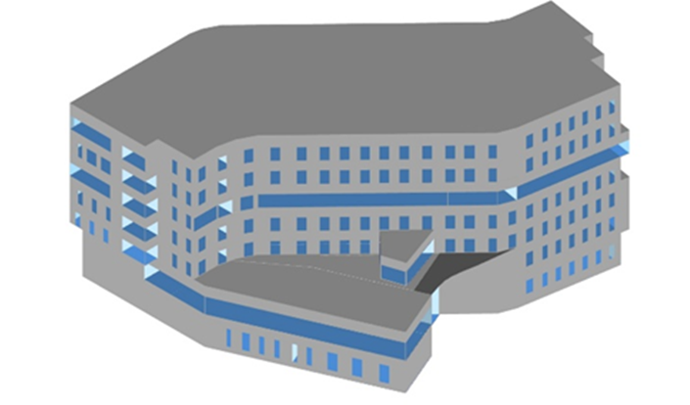
Figure 1: Energy Model

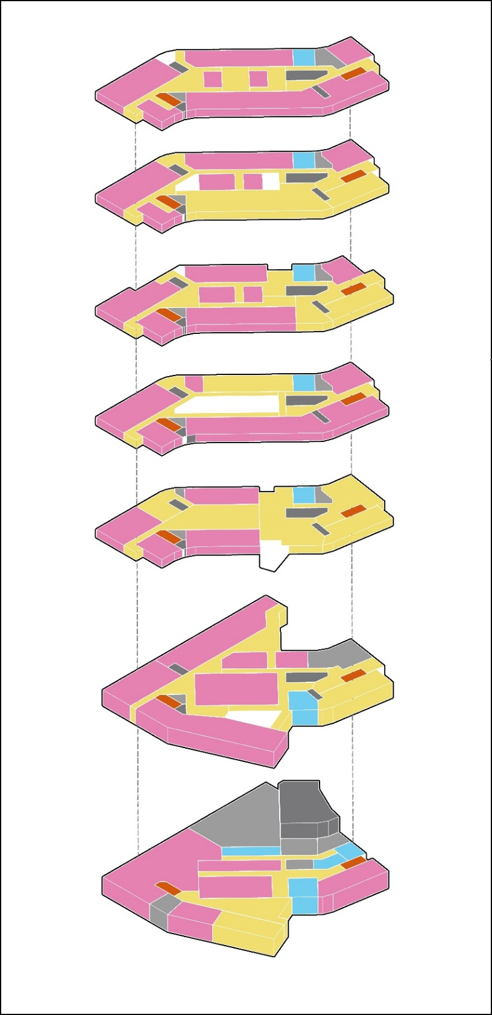
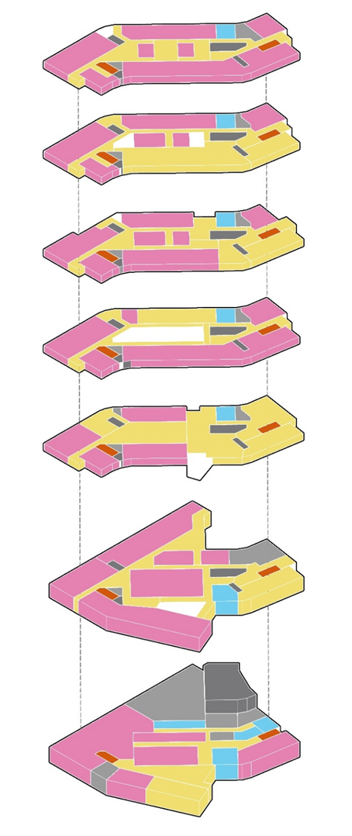

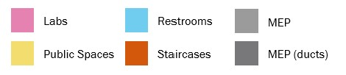
Figure 2: Energy Model Zoning

Climate
The project is based in [location] which is in ASHRAE climate zone [zone designation]. The climate file used in the simulations [insert name of climate file].

Software
[Choose the correct description depending on which program was used, and delete all others:]

[If Honeybee:]
The energy performance was simulated using Honeybee, a program that is an interface for the Department of Energy’s open-source whole building energy modeling (BEM) engine called EnergyPlus. The engine works as a modular system integrated with a heat balance-based zone simulation with time-steps of less than an hour. It simulates performance metrics that demonstrate the building’s thermal loads and energy consumption over a desired period while accounting for the building’s location, massing, envelope properties, internal loads, HVAC plant and refrigeration systems.

[If TRANE TRACE 3D Plus:]
The energy performance was simulated using TRACE 3D Plus, a program produced by Trane and based primarily on the open-source building energy modeling (BEM) engine EnergyPlus, with supplemental features from Trane. EnergyPlus was developed with support from the U.S. Government and Department of energy; it works as a modular system integrated with a heat balance-based zone simulation with time-steps of less than an hour. It simulates performance metrics that demonstrate the building’s thermal loads and energy consumption over a desired period of time while accounting for the building’s location, massing, envelope properties, internal loads, HVAC plant and refrigeration systems.

[If eQuest:]
The energy performance was simulated using eQUEST, a building energy modeling (BEM) program developed by James J. Hirsch & Associates in conjunction with the U.S. Department of Energy. eQUEST uses the DOE-2 simulation engine, which performs hour-by-hour calculations of building thermal performance and energy consumption. The program models performance metrics that demonstrate the building’s thermal loads and energy use over a specified period while accounting for the building’s location, geometry, envelope characteristics, internal loads, and HVAC systems. eQUEST provides both a detailed simulation mode for advanced users and a simplified wizard interface for schematic design analysis, allowing for the evaluation of design alternatives and the impact of various efficiency measures.

Virtual Rates

The following virtual unit rates for energy costs and carbon emissions were used:

Utility Information | Units | Electricity | Gas | Additional Fuel | District Cooling | District Heating
Unit CO₂e Emissions | (kg CO₂e/kBtu) | - | - | - | - | -
Unit Energy Cost | ($/kBtu) | $ - | $ - | $ - | $ - | $ -

[Please note the source of the cost and emissions data]

Methodology

Metrics

Annual Energy Consumption

Energy consumption measured in kBtu refers to the total energy used in the building per annum. It will include energy for heating, cooling, fans, pumps, lighting, service hot water, and equipment.

Energy Use Intensity (EUI)

The EUI is expressed as kBtu/ft². It’s calculated by dividing the total energy consumed by the building in one year measured in kBtu by the total gross floor area of the building measured in square feet. This normalization of energy consumption is a common way of comparing the energy performance of buildings that may differ in size.

Annual Carbon Emission

Carbon equivalent emissions are a measurement used to compare the climate impact of different greenhouse gases (GHG) by expressing their global warming potential (GWP) relative to carbon dioxide. The emissions are calculated from the building’s annual energy consumption from all energy sources used by the building. The carbon equivalent emissions are measured in kg CO₂e.

Carbon Emission Intensity (CEI)

The CEI is expressed as kg CO₂e/ft². It’s calculated by dividing the total equivalent carbon emissions consumed by the building in one year measured in kg CO₂e by the total gross floor area of the building measured in square feet. This normalization of carbon emissions is a common way of comparing the environmental impact of buildings that may differ in size.

Annual Energy Cost

Energy costs refer to the total estimated annual utility cost of all the energy sources required in the operation of the building. This energy source can be either a single or combined source of power like electricity, fuel oil, gasoline, heating oil, natural gas.

Energy Cost Intensity (ECI)

The ECI is expressed as $/ft². It’s calculated by dividing the total energy cost oy the building in one year measured in dollars by the total gross floor area of the building measured in square feet. This normalization of energy consumption is a common way of comparing the financial performance of buildings that may differ in size.

Simulation Parameters

Envelope Parameters | Units | LEED Baseline | Code Baseline | Proposed
Building WWR Actual | (%)
North WWR Actual | (%)
East WWR Actual | (%)
South WWR Actual | (%)
West WWR Actual | (%)
Wall U-Value | (Btu/h·ft²·F)
Roof U-Value | (Btu/h·ft²·F)
Exposed Floor U-Value | (Btu/h·ft²·F)
Slab on Grade U-Value | (Btu/h·ft²·F)
Assembly U-Value | (Btu/h·ft²·F)
Glass U-Value | (Btu/h·ft²·F) | N/A | N/A
Glass SHGC
Glass VLT
Vertical Weighted U-Value | (Btu/h·ft²·F)
Vertical Weighted R-Value | (ft²·h·F/Btu )
Infiltration Rate @ 75 Pa | (CFM/ft² façade)

Loads | Units | LEED Baseline | Code Baseline | Proposed
Lighting Power Density | (W/ft²)
Occupant Density | (ft²/person)
Equipment Power Density | (W/ft²)

HVAC Parameters | Units | LEED Baseline | Code Baseline | Proposed
Total Ventilation Air Flow Rate | (CFM)
Ventilation Air Flow Rate per Area | (CFM/ft²)
Total Heating Airflow Rate | (CFM)
Heating Airflow Rate per Area | (CFM/ft²)
Total Cooling Airflow Rate | (CFM)
Cooling Airflow Rate per Area | (CFM/ft²)
Chiller Efficiency | (COP)
Boiler Efficiency | (COP)
DX Cooling Efficiency | (COP)
DX Heating Efficiency | (HSPF)
Heat Pump Cooling Efficiency | (COP)
Heat Pump Heating Efficiency | (COP)
Total Fan Power | (kW)
Fan Power per CFM | (kW/CFM)
Total Pump Power | (kW)
Service Hot Water Thermal Efficiency | (COP)

Exterior Uses | Units | LEED Baseline | Code Baseline | Proposed
Exterior Lighting | (kW) | - | - | -

Detailed Results
The following section outlines the detailed results from the proposed design in terms of energy use, carbon emissions, and energy cost and compares against the baseline(s).

Unmet Hours
Unmet hours in energy models refer to the number of hours during which a building's heating or cooling systems are unable to maintain the setpoint temperatures defined for occupied spaces. In other words, they indicate periods when the indoor environment is too hot or too cold compared to the desired comfort range, despite HVAC systems being active.

ASHRAE 90.1 compliance and LEED guidelines often allow a small number of unmet hours per year (e.g., <300 total unmet hours).

 | LEED Baseline | Code Baseline | Proposed
Heating Unmet Hours | - | - | -
Cooling Unmet Hours | - | - | -

End Use Breakdowns

Energy Consumption

End Use | Units | LEED Baseline | Code Baseline | Proposed | LEED | Code
Heating | kBtu | - | - | - | 0.0% | 0.0%
Cooling | kBtu | - | - | - | 0.0% | 0.0%
Lighting | kBtu | - | - | - | 0.0% | 0.0%
Exterior Lighting | kBtu | - | - | - | 0.0% | 0.0%
Equipment | kBtu | - | - | - | 0.0% | 0.0%
Exterior Equipment | kBtu | - | - | - | 0.0% | 0.0%
Fans | kBtu | - | - | - | 0.0% | 0.0%
Pumps | kBtu | - | - | - | 0.0% | 0.0%
Heat Rejection | kBtu | - | - | - | 0.0% | 0.0%
Humidification | kBtu | - | - | - | 0.0% | 0.0%
Heat Recovery | kBtu | - | - | - | 0.0% | 0.0%
Water Systems | kBtu | - | - | - | 0.0% | 0.0%
Refrigeration | kBtu | - | - | - | 0.0% | 0.0%
Generators | kBtu | - | - | - | 0.0% | 0.0%
- | kBtu | - | - | - | 0.0% | 0.0%
- | kBtu | - | - | - | 0.0% | 0.0%
Renewable Energy | kBtu |  |  | -
Total Site Energy Use | kBtu | - | - | - | 0.0% | 0.0%
Energy Use Intensity | kBtu/ft² | - | - | -
Regulated Loads | kBtu |  | - | - |  | 0.0%

Carbon Emissions

End Use | Units |  | LEED Baseline |  | Code Baseline |  | Proposed |  | LEED |  | Code
Heating | kg CO2e |  | - |  | - |  | - |  | 0.0% |  | 0.0%
Cooling | kg CO2e |  | - |  | - |  | - |  | 0.0% |  | 0.0%
Lighting | kg CO2e |  | - |  | - |  | - |  | 0.0% |  | 0.0%
Exterior Lighting | kg CO2e |  | - |  | - |  | - |  | 0.0% |  | 0.0%
Equipment | kg CO2e |  | - |  | - |  | - |  | 0.0% |  | 0.0%
Exterior Equipment | kg CO2e |  | - |  | - |  | - |  | 0.0% |  | 0.0%
Fans | kg CO2e |  | - |  | - |  | - |  | 0.0% |  | 0.0%
Pumps | kg CO2e |  | - |  | - |  | - |  | 0.0% |  | 0.0%
Heat Rejection | kg CO2e |  | - |  | - |  | - |  | 0.0% |  | 0.0%
Humidification | kg CO2e |  | - |  | - |  | - |  | 0.0% |  | 0.0%
Heat Recovery | kg CO2e |  | - |  | - |  | - |  | 0.0% |  | 0.0%
Water Systems | kg CO2e |  | - |  | - |  | - |  | 0.0% |  | 0.0%
Refrigeration | kg CO2e |  | - |  | - |  | - |  | 0.0% |  | 0.0%
Generators | kg CO2e |  | - |  | - |  | - |  | 0.0% |  | 0.0%
- | kg CO2e |  | - |  | - |  | - |  | 0.0% |  | 0.0%
- | kg CO2e |  | - |  | - |  | - |  | 0.0% |  | 0.0%
Renewable Energy | kg CO2e
Total Carbon Emissions | kg CO2e |  | - |  | - |  | - |  | 0.0% |  | 0.0%
Carbon Emissions Intensity | kg CO2e/ft²
Regulated Loads | kg CO2e |  |  |  | - |  | - |  |  |  | 0.0%

Energy Cost
Energy Cost
Description | Units | LEED Baseline |  | Code Baseline |  | Proposed |  | LEED |  | Code
Heating | $/yr |  |  |  |  |  |  | 0.0% |  | 0.0%
Cooling | $/yr |  |  |  |  |  |  | 0.0% |  | 0.0%
Lighting | $/yr |  |  |  |  |  |  | 0.0% |  | 0.0%
Exterior Lighting | $/yr |  |  |  |  |  |  | 0.0% |  | 0.0%
Equipment | $/yr |  |  |  |  |  |  | 0.0% |  | 0.0%
Exterior Equipment | $/yr |  |  |  |  |  |  | 0.0% |  | 0.0%
Fans | $/yr |  |  |  |  |  |  | 0.0% |  | 0.0%
Pumps | $/yr |  |  |  |  |  |  | 0.0% |  | 0.0%
Heat Rejection | $/yr |  |  |  |  |  |  | 0.0% |  | 0.0%
Humidification | $/yr |  |  |  |  |  |  | 0.0% |  | 0.0%
Heat Recovery | $/yr |  |  |  |  |  |  | 0.0% |  | 0.0%
Water Systems | $/yr |  |  |  |  |  |  | 0.0% |  | 0.0%
Refrigeration | $/yr |  |  |  |  |  |  | 0.0% |  | 0.0%
Generators | $/yr |  |  |  |  |  |  | 0.0% |  | 0.0%
- | $/yr |  |  |  |  |  |  | 0.0% |  | 0.0%
- | $/yr |  |  |  |  |  |  | 0.0% |  | 0.0%
Renewable Energy | $/yr
Total Energy Cost | $/yr |  |  |  |  |  |  | 0.0% |  | 0.0%
Energy Cost Intensity | $/ft²
Regulated Loads | $/yr |  |  | - |  | - |  |  |  | 0.0%

[This section should be removed for compliance-based models and only included for comparisons of different design alternatives for

Design Alternatives

Summary
The annual metrics used to measure energy efficiency are energy consumption, energy use intensity and energy costs.
Annual energy cost is the basis for LEED minimum and optimized energy performance credit referencing LEED v4. Annual Energy Consumption and Annual Energy Use Intensity is used to measure compliance with the
Massachusetts Stretch Code.

Summary Tables

Summary Table Name
Insert Table

